Joaquin Salas

UIN: 731000141

ECEN 325 – 512 Prelab 1

8/30/23

Part 1 – Calculations

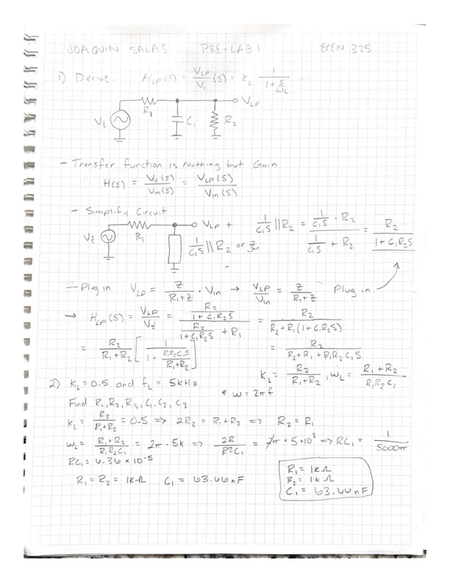

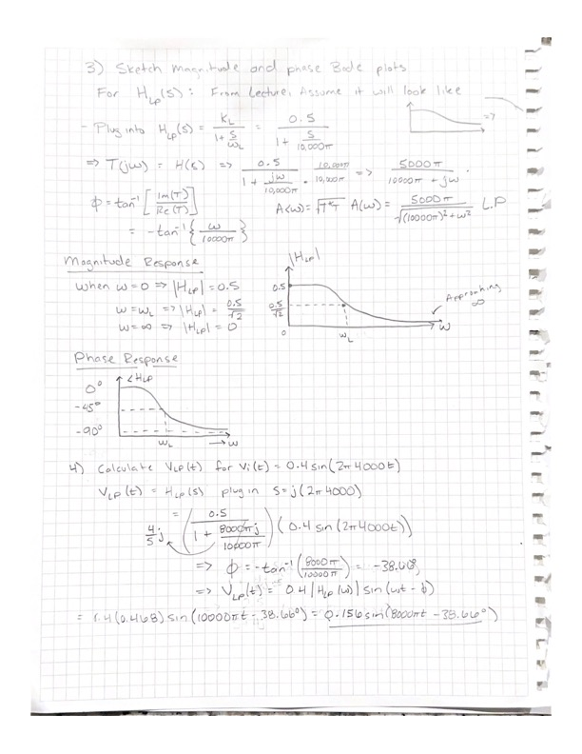

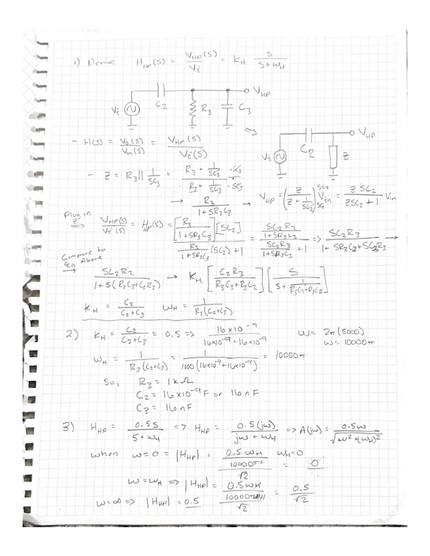

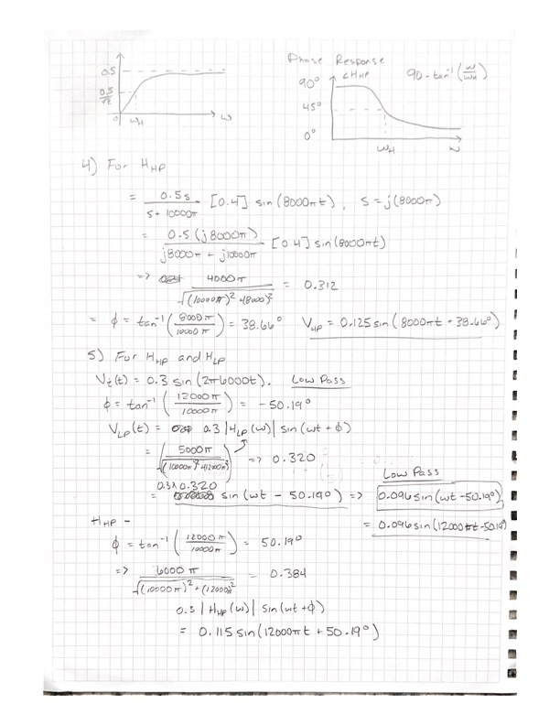

Part 2: Simulations

1. Low Pass Filter Bode Plot at 4kHz and 4mV.

1. Low Pass Filter Bode Plot at 6kHz and 3mV.

1. Low Pass Filter Waveform Graph at 4kHz and 4mV.

1. Low Pass Filter Waveform Graph at 6kHz and 3mV.

1. High Pass Filter Bode Plot at 4kHz and 4mV.

1. High Pass Filter Bode Plot at 6kHz and 3mV.

1. High Pass Filter Waveform Graph at 6kHz and 3mV.

